Project Title: NEXUS AI – Intelligent Research Workspace & Admin Control
(Basic HTML, Hyperlink and Commenting code)

- Admin-side (minimum 5 screenshot of webpages)

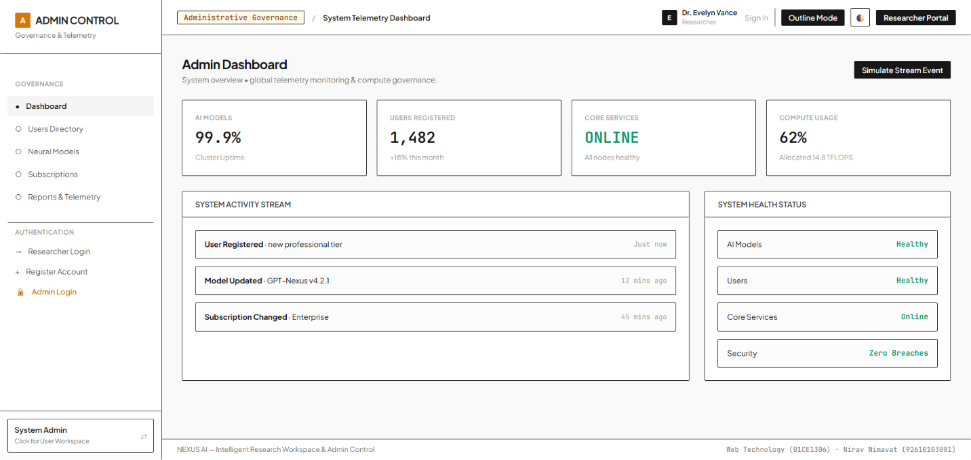

fig. 1.1 Admin Dashboard screen

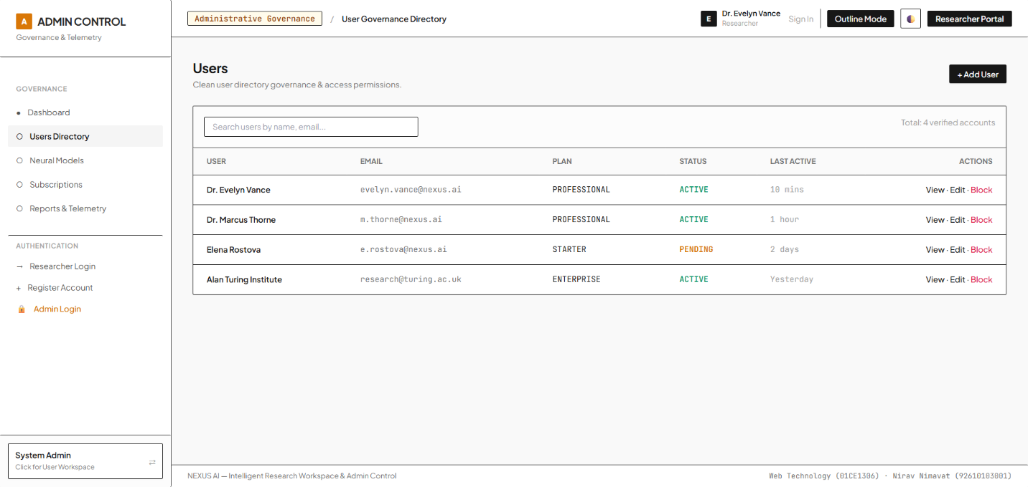

fig. 1.2 Users screen

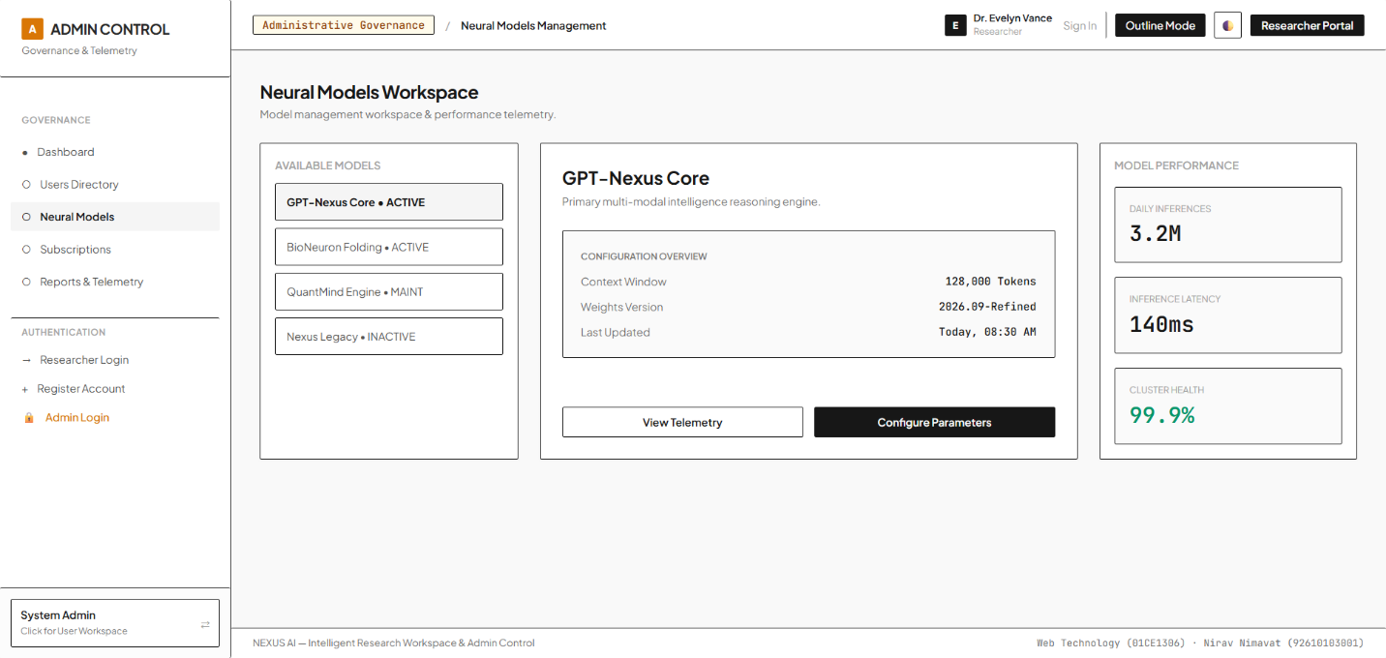

fig. 1.3 Neural Models Workspace screen

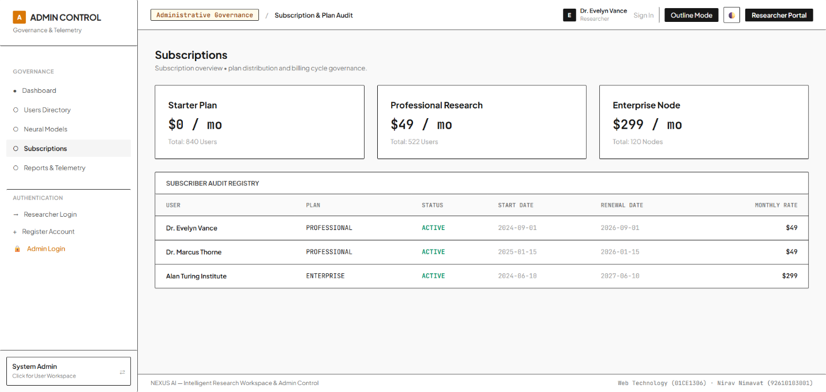

fig. 1.4 Subscriptions screen

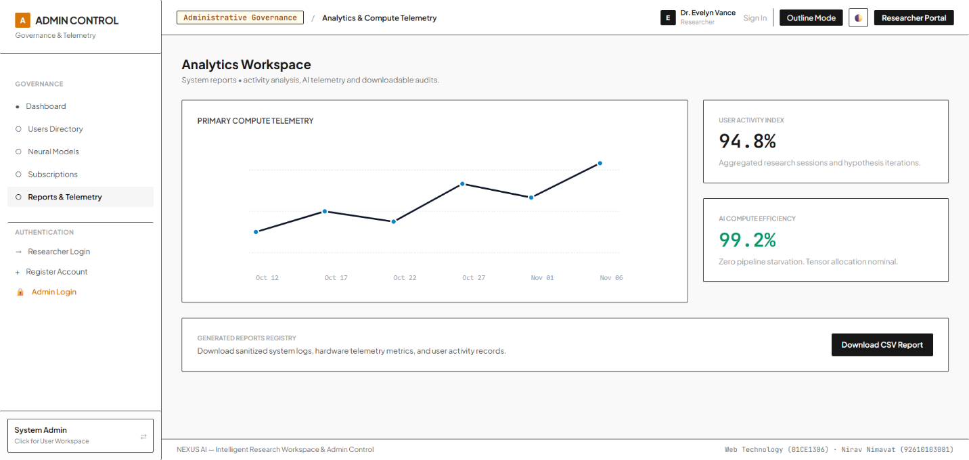

fig. 1.5 Analytics Workspace screen

